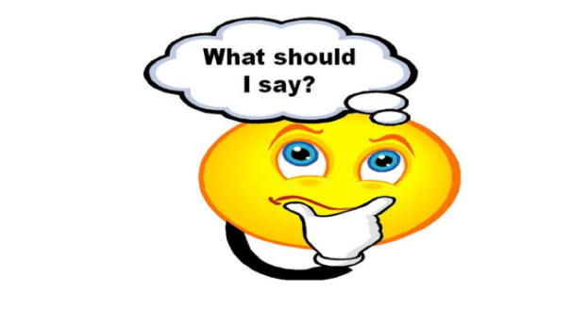
- ….when I come in :
Sorry, I’m late/ I apologize for being late 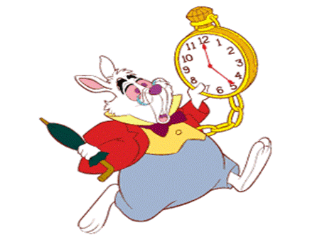
I missed the bus 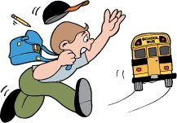 / I forgot to set my alarm clock
I’m sorry, I have forgotten my book/ my linkbook/ my copybook 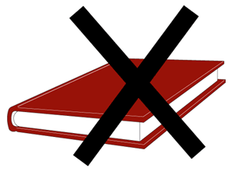

- …..when the teacher calls the roll:

Here/ present
He/she may be ill/ sick…
he/she is not here 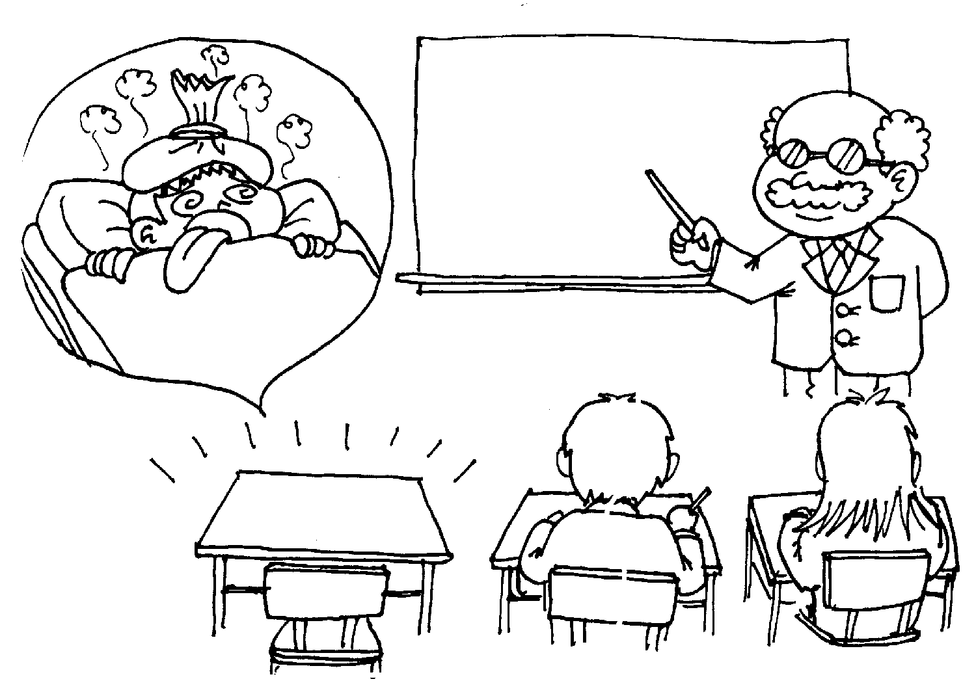

- …..when I don’t understand:

Pardon? / I beg your pardon?
Sorry, I didn’t hear the question/ I didn’t understand what you said
Sorry, I wasn’t listening
Could you repeat please? Could you speak more slowly?

- ……when I have a problem:
I don’t feel very well/ I feel sick.
May I go out, please?
Can I go to the sickroom/ nurse’s office, please? 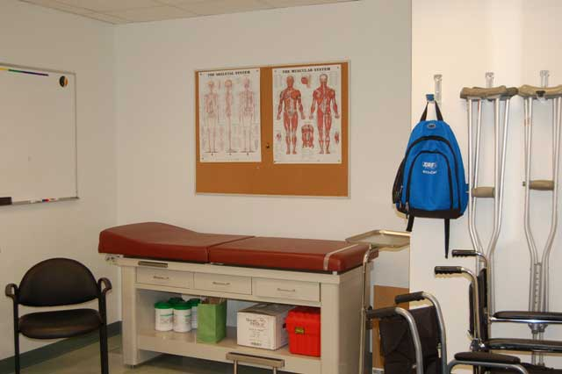
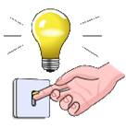 Can you switch on the light , please?
Could you write this on the board, please?
Can you move aside, please
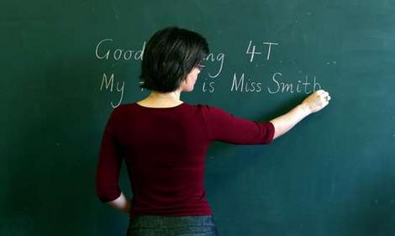

- At the end of the lesson
When is this homework for?
What is our homework for the next class?

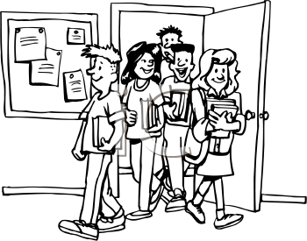 See you on Friday. Bye Bye
Have a nice weekend.

