ZERO TO HERO
The characters (write their names):
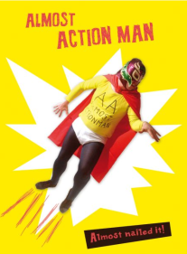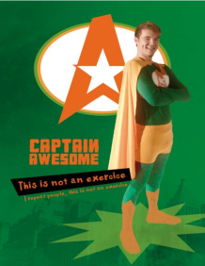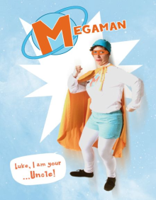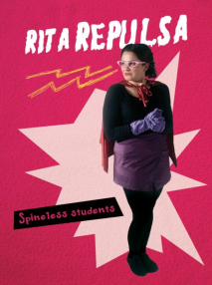
_______________ _______________ _________________ ________________ _____________

Who says what ?
“ I am the coolest and bravest superhero !” ____________________________________
“I am evil and I want a lot of money ! “ ________________________________________
“Susie is my sidekick” _____________________________________________________
Megaman is my uncle ____________________________________________________

