Malteaser

We were cursing the Gods. How could we have got snared down there?
What a shame! My colleague & myself had never been so disoriented. We really didn’t know how to get out from this maze. We were so keen on listening to our guide’s explanations that we had forgotten our pupils for a moment.
That was it. When we came back to our minds after a few minutes of bliss, the guide – named Sarah – had disappeared & we were on our own for closing time is very important in Malta (a regular civil servants nation inherited from the time when the British conquered the island after Napoleon I had plundered it in 1798).
Our 2 colleagues had disappeared as well. We lost them in the maze of the Inquisitor’s Palace in La Valette. We had formed 2 groups of about 20 students & started to explain about the history of this big Mediterranean island halfway between Europe & Africa. Some of them were listening to us (very few of them whereas a great majority were playing hide & seek in the corridors of the museum)
I’ve always been ashamed of accompanying French students abroad. A group of French students is unpredictable - unlike any other group of any other nationality (even the Italians). You start telling them “divide into 2 groups”; then you find 13 students in one group & 27 in the second group. After parleys & lots of diplomacy, you succeed in having 15 in one group & only 25 in the other one. It all depends on the pupils. The teachers have nothing to do with that. It’s their trip & no one could ever change their minds about that though they’d have sworn any pledge of allegiance at the 4 or 5 briefings previous to the schooltrip (in the presence of their naïve parents).

Napoleon Buonaparte invaded Malta & stole all the booty on the island before his fleet was sunk by Admiral Horatio Nelson in 1798 in the Bay of Aboukir - 32 miles off the coast at the north east of Alexandria – that’s where the Templars treasure is probably to be investigated for.
But Napo came back to France – letting his soldiers (not yet veterans) to fend for themselves against the Turks & the British to prepare his putsch at the Tuileries on 9th November 1799 (“le coup d’état du 18 brumaire”).
That’s all we had learnt, along with the defeat of the Turks in La Valette’s harbor bay in 1565. But it was getting dark by then & we were progressing very slowly along the dimly-chandelier lit corridors of the ancient fortress. Suddenly, the lights went out. It must be closing time at 7:00 pm.

What else could we do Mrs Monfort & myself than watch the videos tracing back the victory of the Templars over the Turkish fleet in 1553 & wondering about what would happen to our pupils if Jérôme & Carine (our 2 colleagues) hadn’t taken care of them. We were trapped! No one to call to for I hadn’t got the international contact & Mrs Monfort had forgotten her mobile she didn’t know where. Suddenly, the screens reenacting Malta’s siege by the Turks in 1565 went blank.
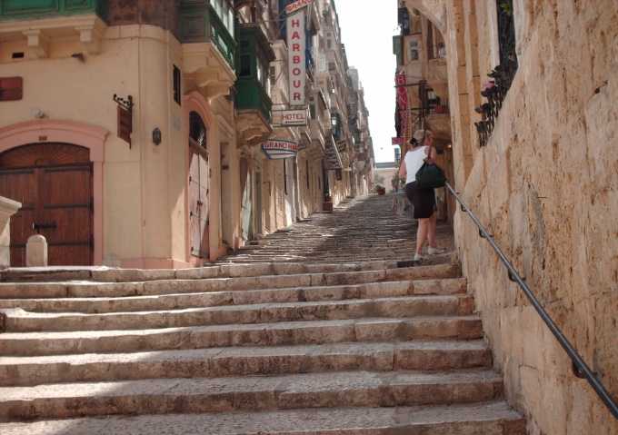

We were trapped.
We crouched on sofas & started sleeping as the day had been particularly exhausting due to the sun & our unruly students. After a few minutes, I could hear Mrs Monfort snoring. We had started very early from our high school in Troyes (lycée Marie de Champagne). A bus had shuttled us up to Paris – Roissy Charles De Gaulle airport. Then we had flown over southern France & the western coast of Italy (a 1 ½ hour flight). We could see Sicily & the small Lampedusa island from above– which has become so famous because of African immigration to the EU today. We were a bit anxious at the landing for La Vallette’s airport is situated right along the coastline (what if the pilot misses his landing?). Our students were so pleased he did it properly that they applauded him (or her).
Such a long journey had exhausted us. The schoolyear was almost over & all we wanted was take a holiday before the bac 3 months after (it was april time).
The bac is the equivalent of the A level in England. All along the schoolyear, Mrs Monfort had organized reunions with the parents of our students (3 or 4 at least) to come to that result! What a hell! where is French national education heading to?

I had eventually come to sleep when a whining woke me up. I prodded on my elbow. Mrs Monfort was fast asleep & uttering bizarre sounds. Suddenly, the television started to show pictures of the Inquisition. Mrs Monfort was being tortured & the Grand Inquisiteur was making her swallow huge quantities of water to relapse her. She was lying fettered on a big oaken plank & moaned as the Great Inquisitor tried to pour more & more water into her mouth (on an island where water is so precious!).

I was wondering why the Grand Inquisitor wanted her to relapse her faith for she was a regular churchgoer every Sunday morning at St Pierre & Paul Cathedral in Troyes (maybe their files hadn’t been properly uploaded). Anyway, Mrs M must have been a great medium for I could see her on screen as well as by my side. I was flabbergasted. Then the screen went blank & I went back to sleep while Mrs M was still moaning.
We were woken up during the night by a warden who flashed his torchlight right in our faces. He said something like “Whutr u doing here?” It’s true, the adverts iinviting you to speak English under the sun are a little tricky for you’ll never hear that kind of English in London except in Indian restaurants- We told him that we hadn’t paid attention to the closing time as the weather was so gorgeous outside & we didn’t know why we had forgotten the time (which is the same as in France by the way).
We explained to him all that had happened since departure time & that we had lost our pupils & all that stuff… His stern face brightened up into a smile as he was realizing we were his ordinary stuff.
“Don’t wurry lads! It happens every night; I think your pupils are having a good time for it’s the beginning of the touristic season here in Malta”. We wondered what he meant but were so pleased of being released from that inquisitorial prison that we both kowtowed to him. He was carrying such an impressive bundle of keys that he could have locked us up back if he wanted for sure!
He opened the gates of the museum for us with his keys that must have dated back from Malta’s siege by the Turks in 1565 & out we went. Dazzled by the street lights but free, we took a late bus & headed to St Julians’ (a residential district of Valetta) where we were – as well as the majority of our students – accommodated. We could admire the beauty of that city at night, which succeeded to become as attractive as Ibiza. The weather here is so ideal that you could spend your lifetime watching the old men playing bowls, or the tourists – mainly English – doing their shopping & relaxing from the rat race.
We were sitting on the bus when Mrs Monfort nudged me: “I think I’ve seen Tristan; he was dancing on the street with others I couldn’t identify!”
“Oh! Don’t worry” I answered her - for I was still under the effect of seeing my colleague in the hands of the Great Inquisitor - “We’ll see to it tomorrow”.
The bus stopped huffing & puffing – It’s true that Malta’s yellow buses date back from the 1950s. You always fear the engine would come out from under the bonnet under the strain as the city of Valetta is very hilly. The drivers are real pros who can gear in & out the antediluvian monsters. They’re part of the city’s life & the drivers will always accept to do an additional ride to fetch a group of visitors anywhere you are - if you ask them politely early in the morning - for free (that’s what we did for our visits).

When we got down from the bus – at 12:30 pm we found ourselves in a sort of street rave party. We recognized most of our students who had promised “no smoking, no sex, no alcohol” & had even signed a waiver under the control of their welfaring parents (my foot).What else could we do than stay there & watch over them (for they had obviously trespassed their promises)
That’s the time when we saw Jérôme & Carine – our 2 younger colleagues- waving like mads at the sound of the electropop. We looked at each other & understood everything. We were both so knackered that we couldn’t react. So we left Jérôme & Carine to take care of our students & walked uphill to bed in our host families (enough is enough).
On the following day, we waited until 9:00 until seeing our young colleagues arrive. Their eyes were sleepy & red & they didn’t stop yawning. We didn’t dare to ask them at what time they had gone to bed. Progressively, all the students started to arrive at the meeting point: the yellow buses departure point at the entrance of the venerable city of Valetta.
Everyone was already sweating though it was only 10:00 am. After counting at least 7 times our students, we gave our driver the departure signal. We headed for the south east of the main island, to the typical port of Marsaxlokk. The language spoken by the Maltese is a composite of several languages. The Phenicians came first, then the Greeks, then the Romans, then the Crusaders from Europe, then the Arabs, then Napoleon (a blitz visit), then Admiral Nelson conquered it from the French on his way back to England for Napoleon was busy in France becoming an Emperor after letting his soldiers fend for themselves in Aegypt. For all those reasons, Maltese must be very interesting on a linguistic point of view for it’s crammed with foreign influences.
When we arrived at Marsaxlokk, the sun was at its zenith. We took wonderful pictures in the bay with the reflection of the sun on the water. The luzzus are multicolored fishing-boats in which blue is predominant. We went to the small market & bought souvenirs. We had asked our students to take their knapsacks with their pack lunches (provided by the hosting families). Life seemed ideal under the early spring sun. Then we trekked St Peter’s Pool. It is said that St Peter himself used to take baths there & we were decided on trying the experiment of a baptismal bath. After a 2-hour walk under the scorching sun – we began to learn a little more about the previous night – we dragged the weakest students to St’ Peter’s beach where they collapsed down & fell asleep, still toting their knapsacks. The water seemed so inviting & fresh after such an ordeal that lots of us took the plunge (but we were protected by St Peter!).
After, 4 blissful hours, we had to go back to Marsaxlokk. But the effect of the plunge was quite lost when we arrived. That’s when we noticed (for the sun was a little lower) that Malta was teaming with rabbits (no wonder it’s a typical Maltese dish). The coach driver was about to go back to the terminal without us when we arrived, exhausted & soaked in sweat. The huffing & puffing of the bus didn’t arrange things so that we were all pleased to say goodnight to each other at the buses terminal.
We were almost sure that our students wouldn’t attempt transgressing the rules that night.

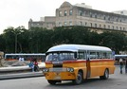
Such wasn’t the case on the next morning for we had to wait at the bus terminal for more than 1 hour before getting back our flock – or rather herd of 46 students. Some of them were very excited & claimed not having slept all night. How could that be? They were all frazzled when we arrived at St Julian’s the night before. Teenagers can recover very quickly for sure!
St John’ Cathedral is the place where the Templars Great Masters are buried. It’s a masterpiece of baroque art. There are lots of Caravaggio’s paintings (the inventor of chiaroscuro). He seemed to have had to take refuge in Valetta for he had problems in Italy. As a consequence, you can watch most of his paintings displayed in the Cathedral. Lots of people queue up to visit that monument & the girls in our group were very surprised to be told to cover their shoulders - though Mrs Montfort had warned them 700 times before – a probable aftermath of listening to loud music with headphones!
Valetta’s St John’s Cathedral is divided into langues sections as there were so many people who conquered this crucial island in the Mediterranean sea half way between Europe & Africa. So, after visiting the sacristy & Grand Master’s Zandalari’s chapel , you can direct your steps to the chapel of the langue of Italy or France or Germany, even Auvergne. But you mustn’t set foot on the big carpet covering the vault or you are excluded by wardens who strictly enforce the rules– as lots of non-Christian people from all over the world come over to Malta.
I was visiting the gallery upstairs with Mrs Monfort & my 2 other colleagues (Carine & Jérôme), we were talking together – feeling free for once since departure time from our students – when I asked them “what about a pint at The Dubliner’s tonight?” (for Malta has adopted the Anglo-Saxon culture since the British invasion in 1800). As no one was answering, I could notice that I was by myself contemplating a painting by Caravaggio (“Bacchus” painted around 1594). Then I sauntered all along the gallery to watch more & more baroque paintings & sculpture masterpieces.
Watching paintings in a museum is very interesting for grown-ups – we know it well in education – you have to vary your activities during a school trip or the students get bored very rapidly for they lack the basic knowledge to understand what they see & listen to. That’s the reason why we had decided to stay only one and a half hour at Valletta’s St John’s Cathedral. There remained half an hour before meeting our unruly flock (or rather herd) at the entrance gate of the Cathedral. I started picking them up in the Chapel of the langue of Aragon – a group of 5 girls who were really very nice in class & very assiduous – but were now talking there about some “cute” boys in the group. I had to remind them their pre-departure waifs & promises as well as the meeting time. They ogled me as if I was talking double Maltese & one of them even giggled. I didn’t insist & went my way through chapel of the langue of Auvergne (it’s true that Auvergnats are reputed for speaking a special kind of French) had a rush at the chapel of the Lady of Philermos. It was a dead end. So I went back to the langue of Auvergne’s chapel. I met 2 very shy bullied boys of the group who were taking photos though it was forbidden & told them to stop. They eyed me as if I was the Great Inquisitor in person but complied.
I turned right after that, walked past the sanctuary & then turned right into the chapel of the langue of France with a view to summoning up the maximum of our students for I knew very well that we would have to wait at least half an hour to get back our herd. I could guess this aisle of the Cathedral led to a dead end too. Nevertheless, I decided to do it thoroughly – probably to bring back some lost heads. I hurried through the chapel of the langue of Provence (no one in there; I was beginning to wonder if I hadn’t got lost myself & there were only 5 mn left before getting back to the meeting point at the entrance gate.
I erupted into the chapel of the Anglo-Bavarian langue (how odd that language must have sounded!) which is also the Crypt of the Grand Masters. It was very dark in there but I could still make out a faint figure between two orating statues of Great Masters. For sure, it was her - Mrs Monfort - with her blond hair shining like a halo in the bright light of the Maltese sun peering through a small circular opening in the ancient wall. She looked like an angel!
As I didn’t want to put an end to her meditation, I waited patiently for about 10 mn. Then she seemed to recover her spirits & realized someone was watching her. I apologized as if I had just arrived “It’s high time we went… “ I said (the sort of stupid things one says when you’re caught in the act). She immediately got back to her senses and, looking at me right in the eyes said “Let’s go now! our students must be expecting us!”
When we got out of St John’s, dazzled by the Maltese sun at its zenith, all our students were there. Carine & Jérôme were counting them. So, we didn’t lose a single minute & headed to St Elmo’s Fort, back to the reality of the traffic after those long blissful minutes at St John’s Cathedral.

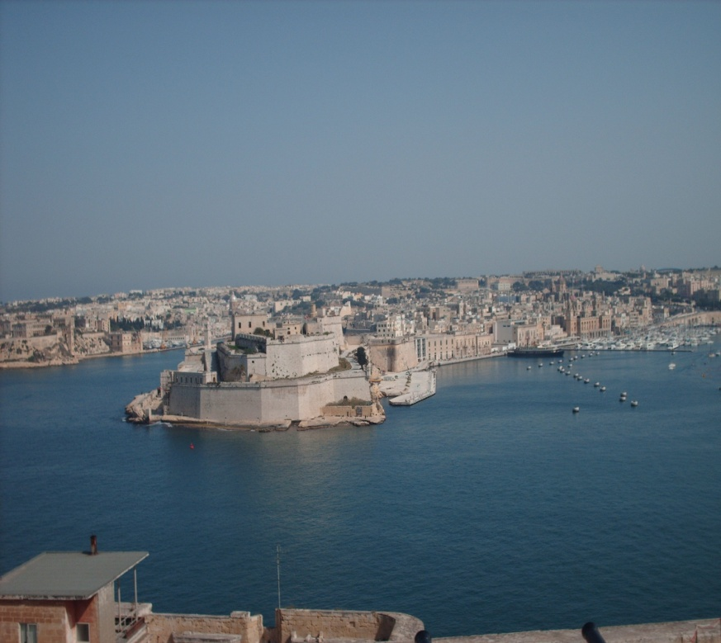

Valletta is a military fortress & it’s not very complicated to keep your bearings in such a city (like Brest in France or Neu Breisach at the Franco-German border). The design consists in square blocks of flats & large avenues which the military can control easily. This is more or less what Baron Haussmann achieved in the 1860s for Napoleon III wanted to avoid another Commune in Paris as in 1848. The main artery in Valletta is Republic Street. When you arrive at the central yellow buses station at the Tritons Fountain, all you have to do is walk straight on through the commercial centre of the city, then walk past Republic Square with all its restaurants & cafés on your right, then Palace Square, the siege of the Maltese government which you can visit for it’s a museum as well. Then the ground begins to recline & you have to go down broad steps & then climb up the hill at the tip of Floriana’s langue where St Elmo’s fort is located (the bastion against the Turks’ siege in 1565). They were repelled by the Templars & it meant the end of their progression in Europe. When you direct your eyes to the right, you can notice 4 “langues” (peninsulas) on the right across the bay. That’s where the Turkish Navy went to smithereens when they tried to sail past Ricasoll Fort, Kalkara, Vittoriosa (named so after the battle) & Senglea. It was hopeless for them as the Knights were not only monks but fierce warriors as well. Their order’s principles had been defined by St Bernard de Clairvaux during the 12th century. King Felipe II of Spain – a fierce defender of Catholicism - sent reinforcements (he was Mary Tudor Queen of England’s husband, Henry VIII’s daughter who had proclaimed himself head of Anglicanism)
After such a history lesson (only for a minority of our students), we deserved well to go back to “Republic Square” for a little rest. We took left 5ish & told them to be right on time for their host families to be able to pick them up at Tritons Fountain. We had bruschietta with muscat wine for an aperitive. We deserved it well after 3 days spent on the island. We watched them bustling to & fro along Republic Street as they were starting to buy a few souvenirs for their families.
What a gas to loiter under the sun, doing nothing, & feel the relaxation of a lazy evening! You reconcile with the whole universe & pardon all your enemies. Such blissful moments are necessary or it wouldn’t be possible to go on living; at least, that’s what we were thinking my 3 colleagues & myself: we were very far from the rat race & wondering how we could have done to bear all the stress of the schoolyear. During those short moments, you really have the impression of being a philosopher, of looking at things through minimizing glasses (the wrong end of magnifying glasses).
Worn out as we all were, we left St John’sCafé in Republic Square around 8:00 pm. We couldn’t see any longer any students in Republic Street & went back to our host families on a yellow bus. After lunch, I went to sleep on my couch which my host family had generously devoted to me (there must have been a communication problem between our French travel agency & the Maltese one). I was starting snoring along with my room-mate Jérôme - accommodated the same way in a tiny room. After talking about all we had had to endure that day whereas our host family’s daughter slept in a double bed in a big room while we had to be content with what we were offered.
We had been rumbling on for about 3 hours when someone knocked at our bedroom door. I proppedup on my elbow & tried to open my eyes while Jérôme was still grunting & exhaling sounds in his sleep. The light switched on & I recognized Mr & Mrs Rosa’s daughter. She was a wearing a see-through mini nightgown & I couldn’t believe my eyes at first as I was very much dazzled by the electric light.
“The police has just phoned” she said “you have to fetch a student of yours who has been brought to the police station in an drunken state!” then she disappeared by magic into her private apartment.
I must have proferred a few curses but it was nothing compared to Jérôme’s when I shook him up…
“censored”
At this time of night, we took a taxi & arrived at the police station to find Tristan – one of our most unruly students - in a cell with some other young people whom we didn’t know. They appeared to have celebrated a little too much. The air was reeking with an acrid smell for they had vomited all over the floor. After enlargement of our pub amateur by the police keys’ warden, we took another taxi to go back to this young man’s address. But he didn’t remember it. So we had to phone Mrs Monfort & Carine who were accommodated in the same family (in much better conditions than we were Jérôme & me). Mrs Monfort sounded wild at the other end & I feared the worst for the young guy who was lying lifeless – as if he had drunk the life out of himself (but I don’t think it’s possible). Then, we had to bang with our 4 fists at the door of his host family to deliver the boy. I can remember the father was very angry for he was working at 5:00 am in a big hotel in Birghu (a Valletta touristical district). Tristan looked like a living corpse. We stayed with him a little outside the house as the taxi ride had churned his bowels. He had puked on the pavement almost on the naked feet of his hosts’ daughter. She told us she was going to take care of him & hugged him around the waist. They went through the entrance gate & disappeared from our view. We apologized to the parents for we felt responsible for this incident. They told us not to worry as they had many problems like that all over the season. It meant the aleas of the job for them. They did it for the money. We shook hands with them before departing.
It was almost 4:00 o’clock. There weren’t any taxis to be seen anywhere. The city was asleep, apart from a few early birds who were probably going to work in the St Julian’s residences to clean before the arrival of the tourists. So we started to walk back to our hosting family. But we didn’t remember the way as we had stayed there only 2 nights. We had been wandering in the streets of St Julian for one hour & a half when we eventually arrived at the entrance gate of our condo, beaconing at the top of a hill. We rang & Mr Axisa opened us. He was still wearing his uniform as he was a nightwatch at the “Suncrest Hotel” (one of the most famous hotels on the island). He had just come back from work & we had breakfast with him as we had nothing else to do than wait for daybreak. It wasn’t long before it happened.
We lay back on our couches for an hour, cursing Tristan & thinking of the terrible chastisement Mrs Monfort would inflict to him.
Mrs Axisa woke us up around 7:30, shouting in our ears with her Maltese accents, rolling her Rs: “Wot wud you like fo breakfast? Grapefruit o bananas”. The previous night had been so trying that we swallowed a second breakfast. After thanking our hostess, we took a shower in the aisle of the condo (a big marble floored room as in many houses in Malta). Then we took a bus to Tritons Fountain, Valletta’s entrance gate. Mrs Monfort & Carine were already there counting the pupils. We were going to Popeye’s village, a site situated at the west of the island, a one-hour bus ride from Valletta.
We were waiting for our latest students when Mrs Monfort received a phone call from Tristan: he couldn’t come to the meeting point for he had gastroenteritis… We looked at each other & all burst out laughing. That was a fine way to begin our journey, huffing & puffing up & down hilly ground to Popeye’s. We were the first visitors on that sunny april morning around 10:30. Our group was immediately spotted by the animators working on the attraction park. They let us discover the attractions. Popeye’s attraction park in Anchor Bay was actually the site of the shooting of a film starring Robin William. The ambiance there features bright colours, boats, swings, weightlifting (plush balls), spinach, Brutus (Popeye’s dedicated enemy) & Olive (his girlfriend).
The animators met us as we were sitting on the tiers at the center of the village. After a few demonstrations of their strength, lifting plush heavyweights to put us in the right mood, they chose me, Mrs Montfort & Carine (Jérôme had shied away) to feature in a film which I still have for I bought the CD shot by the animators of Popeye’s village. The plot was as follows: Popeye has a lot of success with girls (our feminine students + Mrs Monfort & Carine). His fiercest enemy (myself featuring Brutus) leads a group of pirates (some of the boys in our group). We attack Popeye (an animator of the park) who defends himself valiantly for he has eaten spinach. My part is to end up reclining head down on the other side of a fence (like Materazzi at the 2002 world cup final after being headkicked in the chest by Zinedine Zidane).
I did my best & got cheers from the crowd of tourists who were beginning to arrive at Golden Bay. No doubt Mrs Montfort, Carine & myself became very popular among our students after that masterpiece of the seventh art. I’ve always featured losers in all the amateur films I shot in my life (pushed over ramparts by Belphegor, shot down at the bar of a saloon…) Losers are a type of characters I feel close to in cinema.
It was midday when we left Popeye’s village - under the cheers of the tourists who knew now what they had to expect from the animators. Our hosting families had provided us with pack lunches & Jérôme Fontaine was toting the water jerrycan (we thought the pun was quite convenient as he hadn’t dared to play a part in the Popeye film). We picnicked at the top of a hill beaconing over Mellieha Bay, at the northernmost tip of the island. Our students were adorable. There’s nothing like making them breathe fresh air to socialize them. We were conscious of what we had accomplished when we reached the small seaside residence site in Mellieha Bay: even the worst enemies in the group started to feel empathy for each other.
If you watch a group of students especially a group of French students, you might think there’s no love between them, that they spend their time in small groups bullying each other. A school trip is a good way of remediating to this state of things: for once, they’re not competing on the school benches. They live their lives under the guidance of their “favourite” (?) teachers who are pleased to teach them other things than what they are in charge with. That’s why we felt elated as we were running down the slope leading to Mellieha Bay. The water was around 20° C (70°F). We had been toiling uphill for one hour before lunch. We stayed until 5:00 on the beach, under the sun & swimming in the laguna, a true holiday-makers dream worthy of St Tropez.

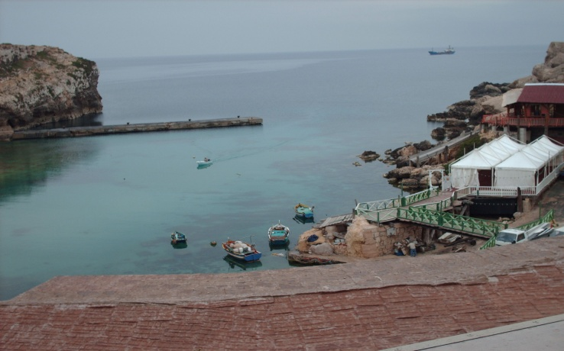

The bus that took us back to Tritons’ Fountain must have dated back from before the WWII for the driver sometimes used both hands to gear in. We feared being thrown into the ditch as the road was very narrow. But that good guy went on talking with us in his strange kind of English, sweating under the setting sun. He must have had a hard day driving his jalopy but it hadn’t diminished his joy of life & good humour. We arrived after one hour & a half of creaking, clanking & ricketing. Even the students, so elated at the start, had stopped chatting for they were more & more anxious. One could feel the angst all over the space.
This time, we felt sure that everyone would spend a long & profitable night as we took leave at the bus terminal. Jérôme & I were a bit sleepy because we hadn’t really had what one could call a goodnight rest. We missed the stop at St Julian’s & had to walk back one kilometer. We were frazzled. On our way home, we could notice lots of plants that are grown in France in apartments. The cacti in Malta grow outside without any human intervention. They can sometimes reach the height of 12 feet (around 4 meters). Why bother staying in France?
Rosette Axisa, our charming hosts daughter opened the door for us. We could notice someone lurking in the darkness of the entrance, a contrast due to the bright day light outside. She introduced us to her fiancé Manoel who seemed decidedly very bashful. We offered to shake hands with him (ungrudging & comprehensive about our seclusion in the sitting room) but he shirked away, muttering a few ununderstandable words in Maltese. Rosette didn’t look pleased & frowned at him as if he was her first child. What a beginning for an idyll! Most girls consider their boyfriend as their first child. That’s why so many couples divorce after 2 or 3 years.
We had a quick wash in the marbled shower & Graziella Axisa, our hostess, called us for dinner. We were so hungry that we could have eaten a horse. We had rabbit stew instead, a standard of Maltese cuisine. After talking in Maltenglish with Manoel & Graziella (Rosette & her boyfriend were in our… or rather their suite) over a glass of excellent muscat, Jérôme & I decided to have a last pint at the Dubliner’s. We phoned Mrs Monfort & Carine & met them around 10:00pm at the pub.
We were relaxedly talking to each other & enjoying the fresh air at the terrace of the Dubliner’s– for the day had been hot & full of fantasy. We were laughing at our performances at Popeye’s village -except Jérôme -when we saw Tristan walking arm in arm with a girl. We all hushed not to be noticed. They stopped right in front of us & exchanged a kiss. We couldn’t believe our eyes! He had promised no sex, no drug, no alcohol! This guy was really shitting the pants out of us! Then they entered the Sun in Splendour Pub, a pub with a beer garden, allowed to under-18 year-old people people. We began to understand everything now – how naïve we had been! – our students were invited to the beer garden by the children of our hosting families according to the law, for you could bring any infant outside a pub; the main thing in British (and Maltese) legislation is not to let children see the disasters of corruption inside a pub, which dates back to the Victorian era at the end of the XIXth century. We decided to wait a little & saw almost all of our students get into the Sun in Splendour club, accompanied by Maltese young people, in couples or in groups, kissing one another or jesting at each other in groups. That’s when we understood the whole range of our responsibilities.
We walked back home around 11 pm. The weather was ideal (around 60° F). We were a little anxious about our students but not too much after all. When we came back home, Graziella & Manoel were watching “Dallas” on TV. They proposed us a nightcap of Arak and we talked to them about our problems with our students. They almost laughed to tears (maybe the effect of Arak). They told us not to worry : “Boys will always be boys” & all that sort of things. We eventually took leave of our host family which we began to appreciate - we exchanged our email addresses - & went to bed (or rather couch).
I was ill all night because of the Arak & went to the toilet at least 2 or 3 times to the marbled toilet at the end of the aisle. Jérôme was snoring like a lord!
When we woke up around 7:00 the next morning, the sun was already beginning shining bright like a diamond in the orient sky. I had dreamed of Rihanna all night (maybe an araknean hangover). I went to the marble showers & noticed someone was already there. I just had the time to retreat, apologizing blatantly & went back to our humble retinue for Rosette & Manoel had preceded me.

That day, we visited Mdina, the former capital of Malta, in the south west of the island. It used to be a place of residence for the Templars. There is quite an impressive Cathedral & the streets look very much like some cities in Yorkshire (Ripon or Skipton). That day, we took a 21 bus to get there from Valletta Tritons Fountain Place. We had a wonderful time visiting the Minster & wandering through the small venelles around it. What a pleasure it was to order ice-creams from the café terraces for it was very hot. We stayed there around 2:00 pm. We toted our knapsacks with –guess what – our pack lunches which we could need in case of emergency as there was a planned trek to Dingli Cliffs (the highest cliffs on Malta Island (a 1-mile trek over the Maltese Highlands).
As Jérôme was very sporty (he used to cycle at least 50 miles every weekend), he took the lead of our group. After 2 miles, everyone was scattered along the way (but Jérôme was first; stalking at cruise speed with his long legs which very few students of the group could keep up apace with). He arrived at the top of Dingli cliffs with a 45 minutes advance. He must have kept in mind the Tour de France yellow jersey as Malta’s colour (as well as the Vatican’s) is the yellow colour.

After a 2-hour – at least – walk uphill, we discovered the wonderful view over the Mediterranean Sea. All the students were frazzled for the hectic rhythm imposed by our group leader (but he didn’t seem to give a damn). Then we took a 131 bus back to Mdina but some students (the fittest ones) preferred to walk back. The schedule between the 2 parties was very hard to coordinate. That’s why we all got back to Valletta around 8:00 pm. That night, we all felt confident that our students would prefer to go to bed instead of raving in the streets or going to pubs. What a big mistake!
We were woken up for 4 of our students had been taken to Malta’s Central Hospital. They had apparently – from the report of the police officer – been brought into custody after a little mayhem in St Julian. When we arrived at the custody room with Jéröme, the policemen on duty recognized us & started shaking hands with us & make us feel at ease (no doubt they were accustomed; it was their routine for sure). As we had lots of red tape to fill out, they offered us a coffee & we were just on time at The Tritons Fountain. Our 4 delinquents weren’t there as they had smoked a bit of ganja. Their mates – especially the girls - felt anxious.
On that day, we visited the Tarxien Catacombs, a Valletta suburb, dating back from Egyptian times (around 3 00 BC). It was a proof that this island had always been important ever since the Mare Nostrum & the Greeks & the Romans. Malta might have been one of the islands described in Homer’s Odyssey. That’s what we tried to explain to our pupils but the notion of 3,000 years ago didn’t seem to impress them for they were actually living in 2007 – a great pace ahead at the commands of the Time Machine. We then gave them free quarters not before listening attentively to our last exposé from our students.
Before leaving from France, Mrs Monfort had make them choose a subject about Malta. They had to work in groups of 5 or 6 & do some research about Malta’s culture & history & economical conditions. It was always a pleasure to listen to these students who suddenly felt intimidated in front of the Maltese people listening to them (some of them even tried to speak a little French). We had great exposés like at the top of Dingli Cliffs or outside Valletta’s covered market. We liked talking to the Valletta people who more or less recognized our job in this way.

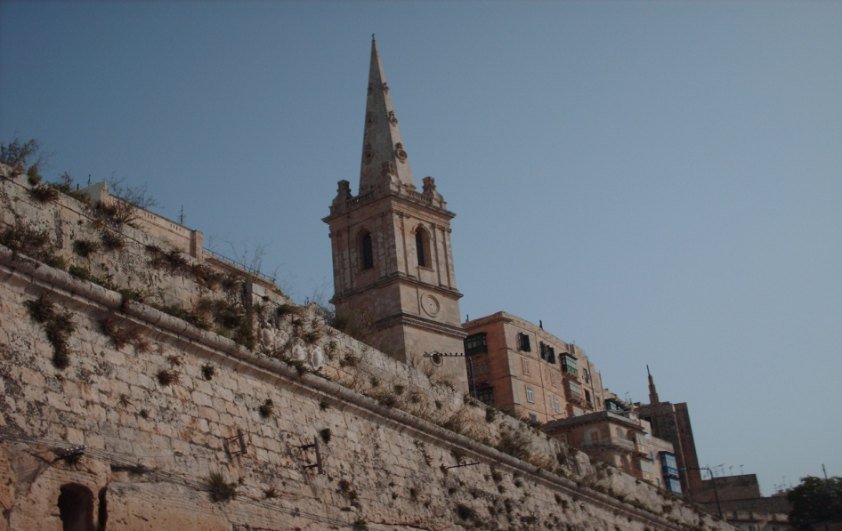

Strangely, we didn’t have any alerts that night. We could sleep all night & felt vey cool & collected on the next morning (our last day in St Julian). We went to Comino Island first & had a great picnic at Blue Grotto (a Paradise on earth). It was high time to ferry back to Valletta for, that night – the last one of our vacation – took place The Malta Experience, the biggest pyrotechnic show in the world. Lots of nations take part in this display. But the Chinese seem to definitely be the best (they invented fireworks). It was an idyllic night – especially between Tristan & Sarah on a sky full of stars & garbs printed behind them as the show went on while each country tried to surpass the other competitors. What a better happy ending for our stay in Malta? We couldn’t have imagined such a wonder when we left Champagne one week before! It was like a fizzing bouquet of colours in the spring Malta orb. It reminded us of our region where the fizzy drink had been invented!

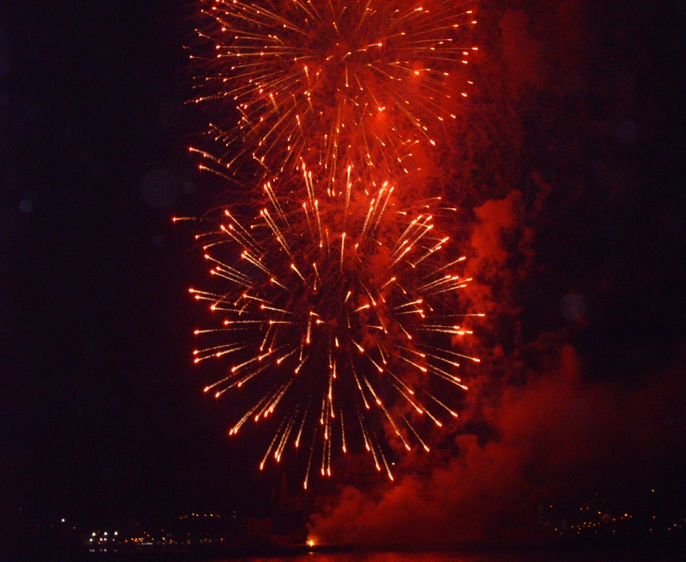

Patrick Remy

