Where were you in 68 ?

We had come back home as there were no more lessons. The high school I was at – like every French school – had closed. Every day, we listened to our transistor radios to get some news from was taking place in Paris. In the evening, I listened to “Salut les Copains”. I knew the words of every English song by heart. At night, I listened to Michel Lancelot’s “Campus” music programme, my ear on the transistor under my pillow to muffle the sound. Every 30 mn, there was a flash news about what was taking place on Boul’Mich in Paris; barricades, students throwing Molotov cocktails, policemen charging at them with their Plexiglas shields, teargas guns & helmets… That was IT; the Revolution had come at last!

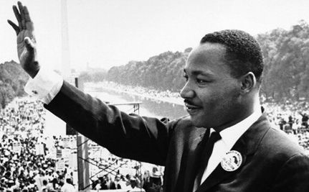

I lived near a military camp & every day, we could hear the sound of the tanks’ engines which were ready to besiege Paris, the place of the rebellion against De Gaulle’s unpopular government. As I was almost 18 years old & in Terminale (upper 6th), I feared to be incorporated to fight the Paris revolutionaries (I would have deserted or refused to wear the uniform)
In the little town’s high school where I was a boarder, there had already been plans to assault the police station (the place where all the evils in the world were allegedly taking place). Our society was going adrift but we didn’t know – especially the younger generation – where we were up to…
We were a little later when President Charles De Gaulle decided to organize a referendum to decide whether he should stay or not at the head of the government. After the start of those events, “Charlot” – as we used to familiarly call him at the time – had emigrated from Colombey-les-2 Eglises (a small village of Haute-Marne) to Colmar where his friend General Massu - with whom he had collaborated in Algeria during the war - could advise him on what conduct to follow during this political crisis.
In my opinion, “Charlot” was a very good president & will be recognized as such throughout the ages – a French resistance hero which he piloted from London – but, in 1968, he had become very unpopular. “Times are a-changing” (Bob Dylan).
Aphrodite Child, a Greek pop group, were on their way to London, the recording Mecca for pop singers at the time, they were travelling from Athens to Paris by train & were stopped there for everyone was on strike. They had on their tablets an everlasting hit “Rain & tears”, actually a very pacifist song which contrasted with the violence on the Paris barricades. Demis Roussos, who has made an international career by now was thin & blond at that time (he’s fatty & black-haired now). Eventually, their single – which I still have – was released in France & made a hit (“après les pavés le sable ” as was tagged on the walls of La Sorbonne)
Neil Young & other singers such as the Beatles sang pacifist songs. Ravi Shankar, an Indian sitar player, played on some of the Beatles records with Georgie Harrison. We were all pacifists. It is to be noticed that there were no victims from the police assaults during the 1968 events – only a student who fell down as he wanted to cross a street on an improvised bridge but he wasn’t killed by the police

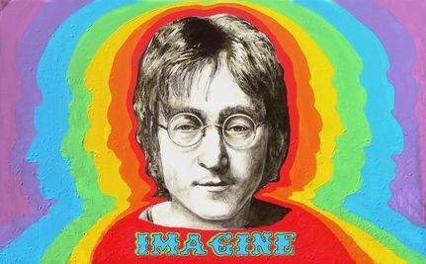

After a 2-month holiday (from May 1968 to the middle of July), we were summoned to the A-level exam tests. The written tests couldn’t have been materially organized as everyone was on strike from petrol-retailers to the researchers at the CNRS (Centre National de Recherche Scientifique). We took oral tests in every subject in front of the teachers who had accepted the examination missions.
That’s how I passed my A-level, the strangest graduation ever!

Then came the holidays. We were not really longing for them as we had been on vacation for more than one month. After those events came the University beginning of term in October 1968. I was in “Fac de Lettres” (College of Letters) in Reims. I studied English as I had always been influenced by English pop music & had already visited England 2 or 3 times
Even after 1968 (George Pompidou had become president after De Gaulle’s referendum), there were problems with law & order in France. There were still demonstrations. I remember once - it must have been in 1970 - Maoist students had organized a demonstration in Reims. Maoists & Trotzkysts used to organize demonstrations which often became riots because of hooded Anarchists who came last & threw Molotov cocktails. That demonstration came to smithereens!
Some Maoist students had been arrested by the police. They had illegally settled a ground belonging to the City of Reims during the Spring holidays to teach children from a poor district, but they didn’t know they were outlaws. They had been arrested & their activities canceled. On Judgement day – a sunny May day reminiscent of what had taken place 2 years before – there were lots of students wating for the sentence in front of the local Court.
We had been waiting for 2 or 3 hours when the verdict came: a suspende 2-week jail condemnation. That wasn’t much (but a pretext that triggered out a riot in a peaceful bourgeois city).
We had been waiting under the spring sun & so had the policemen who had become wild for we threw one-centime coins & didn’t stop jeering at them… When the students who had gathered in front of the local Court House learnt the sentence, there was a surge. Immediately after, as the crowd of students had no intention to go away, the Police Superintendant took the decision to charge at the crowd.

As the Paris Barricades were still in our minds, we all sped away along the main thoroughfare (rue de Vesle) & tried to escape from the police-charging men as they had been exposed all afternoon to the May sun & our jeers. Unfortunately, one of the streets was under repair & we had lots of cobblestones there to re-enact what had taken place 2 years before! That’s exactly what we did, just in front of the central police-station just in front of the Cathedral.
After that, we’d better run away but the policemen chased us & took some students into custody. I was a fast-runner as I played football & could escape the fatty boys from the police-station. Some friends of mine were arrested, taken off their belts & shoe laces. They were kept in custody with the drunks who roamed the streets every night & vomited all over the cell. I think it must have been a good deterrent for them & I might have experienced the same thing.

My opinion is that we took our independence in 1968 but couldn’t enact what we had decided to achieve: that is change the society. We all wanted to be different from Mum & Dad who had been like us during WWII. The capitalistic system took us & we soon yielded to it as there was an ensuing prosperity period. We all had our lives to build up from scratch & profited from that golden opportunity.
Bob Dylan, John Lennon, Neil Young, Jim Morrison, Jerry Garcia, Janis Joplin “Cry cry baby…” where are you my sixties’ idols?
Anyway, your songs’ lyrics were great & made me dream every night as I listened to my transistor under my pillow in the stillness of the night!

I’ll always remember The 1987 Isle of Wight & 1969 Woodstock Festivals!

PEACE & LOVE

P.REMY

